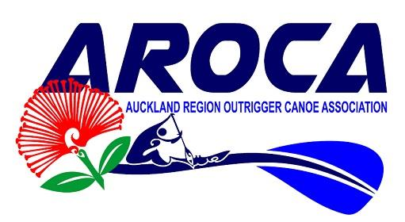

Annual General Meeting Agenda
Date: 21 January 2021
Location: Don Rowlands Centre – Lake Karāpiro
Time: 5.00pm – 6.00pm
Karakia:
Agenda
1. Chair Report
2. Financial Report
3. Nominations – Board position available
4. Strategic Plan
5. General Business

Nga Mihi
AROCA Board

